

**THE IMAGINATION UNIVERSITY PROGRAMME**

**RVfpga-SoC Lab 1**

**Introduction to RVfpga-SoC**

# Introduction :

In this lab, we will show how to build a RISC-V system on a chip (SoC) from building blocks. An **SoC** is an integrated circuit or an IC that integrates an entire electronic or computer system onto it. An SoC includes a core and all of the peripherals and interfaces necessary to load an operating system and run programs. Figure 1 illustrates the typical hierarchical organization of an embedded system starting with the processor core, then the SoC built around the core, and finally the system

and board interface.



**Figure 1. Typical Embedded system**

The design process of an SoC starts with prototyping on an FPGA. Our focus will be on targeting an SoC to an FPGA. The term **RVfpga-SoC** refers to both this course and the RISC-V SoC that we will design in this Lab.

The RISC-V CPU that we will use is the Western Digital’s **SweRV EH1 Core**, and the SoC that we will design in this lab is based on **SweRVolf**. Figure 2 illustrates the various components and how they fit together.

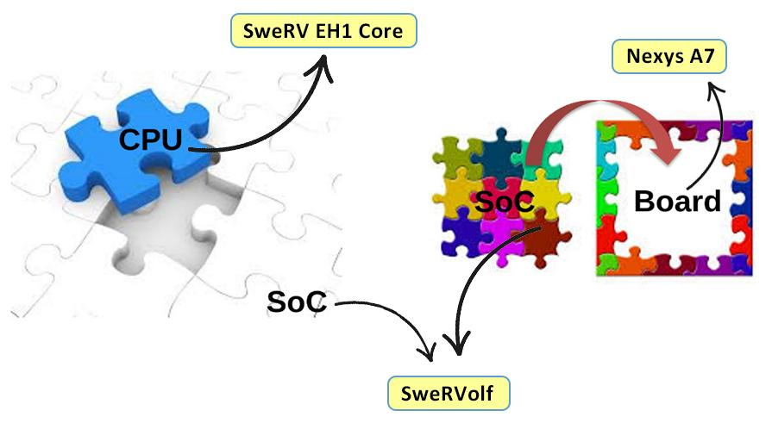

**Figure 2. RVfpga-SoC based Embedded system**

In addition to the SweRV EH1 Core Complex, the SweRVolf SoC also includes a Boot ROM, a UART, a GPIO (general-purpose I/O controller), a Syscon (system controller), an SPI controller, and an interconnect. Figure 3 shows a high-level block diagram of SweRVolf.

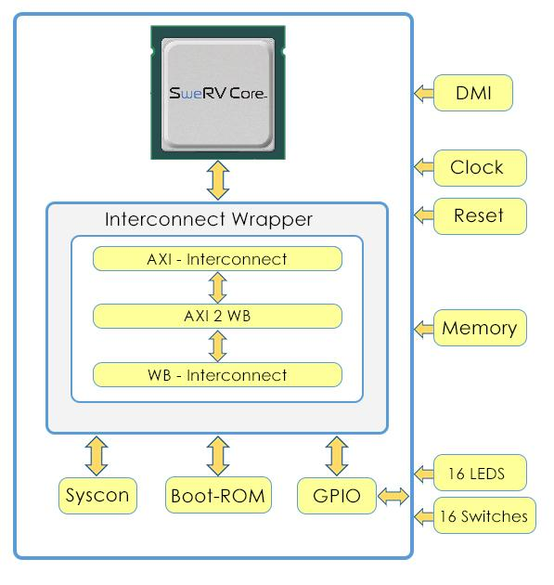

**Figure 3. SweRVolf**

This Lab will be a step-by-step guide that shows how to start with a CPU (the SweRV EH1 Core) and then building it up into an SoC (SweRVolf).

We will be using the Vivado Block Design Tool. Vivado’s block design tool facilitates wiring components graphically, which makes the process easier to understand and visualize. This visual approach also illustrates how each module is connected with the others to form an SoC.

The modules can be classified into three major blocks or categories:

1. CPU (SweRV EH1 Core)
2. Interconnect (Interconnect Wrapper)
3. Peripherals (Boot-ROM, GPIO, Syscon)

For the sake of ease of learning and understanding, some components that make up the Interconnect (AXI interconnect, Wishbone Interconnect, and AXI to Wishbone bridge) have been wrapped into one Interconnect Wrapper block.

|  |
| --- |
| For labs that focus on the CPU and inside the CPU, please refer to the RVfpga course. The RVfpga (also written RISC-V FPGA) course is a package that includes instructions, tools, and labs for targeting a commercial RISC-V processor and SoC to a field-programmable gate array (FPGA) and then using and expanding it to learn about computer architecture, digital design, embedded systems, and programming.  For more information about RVfpga, visit <https://university.imgtec.com/rvfpga/> |

# Requirements :

To complete this lab, you will need to have the following software installed:

* Vivado 2019.2 WebPACK (Refer to Installation Guide)
* Digilent Board Files (Refer to Installation Guide)
* Verilator (Refer to Installation Guide)

**IMPORTANT:** Before starting RVfpga-SoC Labs, we highly recommend completing the RVfpga-SoC Installation Guide.

For example, if you have not already, install Xilinx’s Vivado and Verilator following the instructions in the RVfpga-SoC Installation Guide. Make sure that you have copied the RVfpga-SoC folder that you downloaded from Imagination’s University Programme to your machine.

# Create Vivado Project :

You will use Xilinx’s Vivado Design Suite to build the Block Design and RVfpga system using the RTL, the Verilog files that define the system. Follow these steps, detailed below, to create a Vivado project.

**Step 1. Open Vivado**

If you did not install Vivado on your machine as described in the RVfpga-SoC Installation Guide, do so now. Be sure to install the board files as well.

Now, run Vivado (in **Linux**, open a terminal and type: **vivado**; in **Windows**, open Vivado from the Start menu). The Vivado welcome screen will open. Click on Create Project (see Figure 4).



**Figure 4. Vivado welcome screen: Create Project**

**Step 2. Create a new RTL project**

The Create a New Vivado Project Wizard will now open (see Figure 5). Click Next.

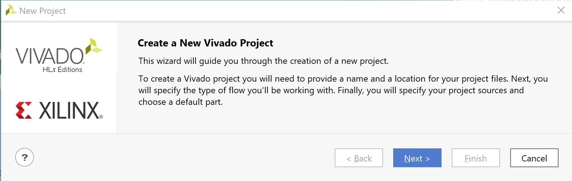

**Figure 5. Create a New Vivado Project Wizard**

Enter the name of the project as “**Lab1**” with no spaces. Then click Next (see Figure 6).

Select the following Project Location Path :

[RVfpgaSoCPath]/RVfpgaSoC/Labs/LabProjects/Lab1

Uncheck the create project subdirectory checkbox because there is already a folder called “**Lab1**” in the “**LabProjects**” folder.

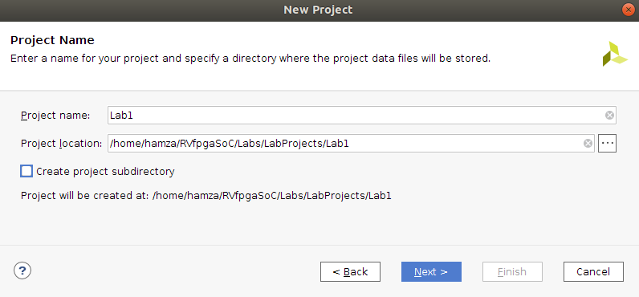

**Figure 6. Project Name**

Select the project type as RTL Project, and click Next (see Figure 7).

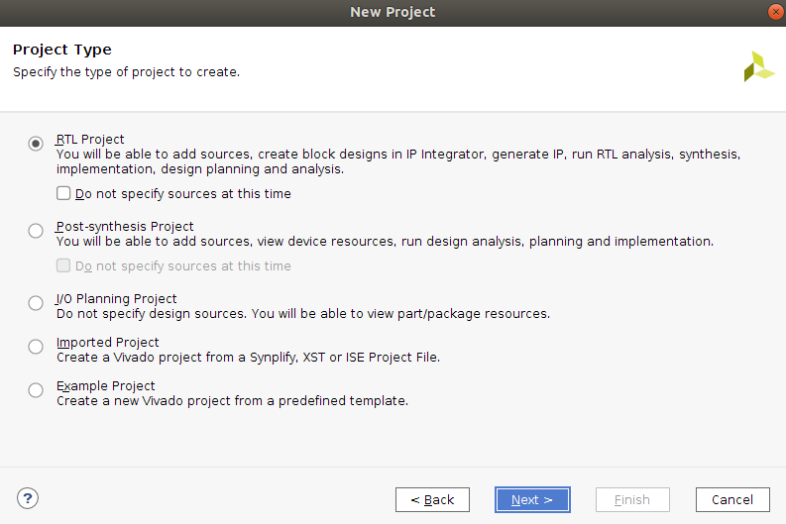

**Figure 7. RTL Project**

**Step 3. Add the RTL source files and the constraint files**

In the Add Sources window, click on “**Add Directories”** (See Figure 8).

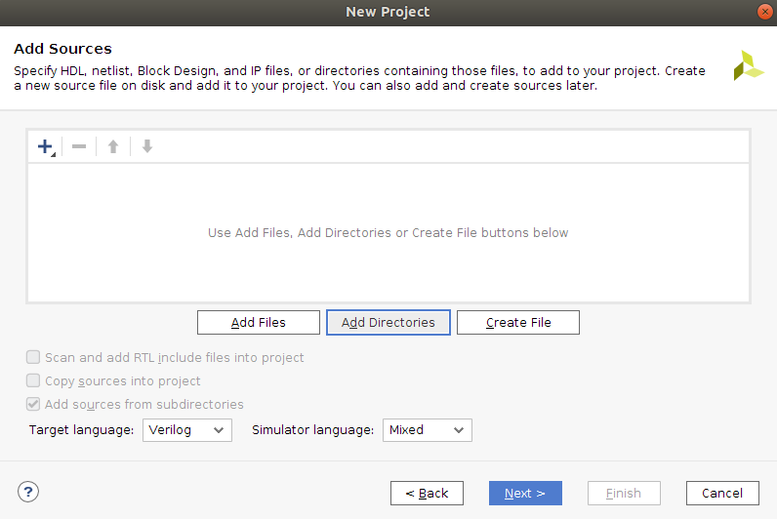

**Figure 8. Add Sources directory**

Now select the “src” directory at the following path [RVfpgaSoCPath]/RVfpgaSoC/Labs/LabResources/Lab1/src (See Figure 9).

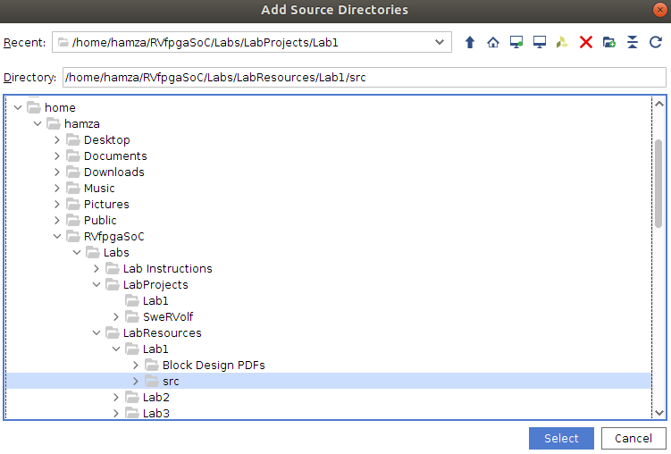

**Figure 9. Select the “src” directory**

Click Select.

Then click on the “**Add Files**” button.

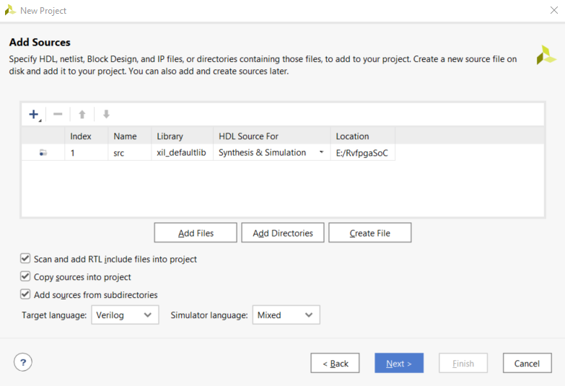

Select the Files type to “**All Files**”. Now navigate to the **LiteDRAM** directory inside the **src** directory that we have just added.

[RVfpgaSoCPath]/RVfpgaSoC/Labs/LabResources/Lab1/src/LiteDRAM

/mem_1.init

[RVfpgaSoCPath]/RVfpgaSoC/Labs/LabResources/Lab1/src/LiteDRAM

/litdram_core.init

Select both the “**.init**” files and click OK to add them both (See Figure 10).

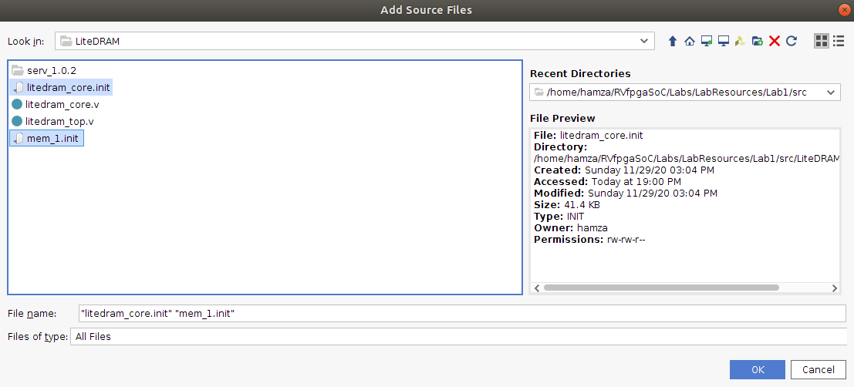

**Figure 10. Add LiteDram Sources Files**

Make sure all three of the checkboxes are checked (see Figure 11).

Click “**Next**” to proceed to the next step.

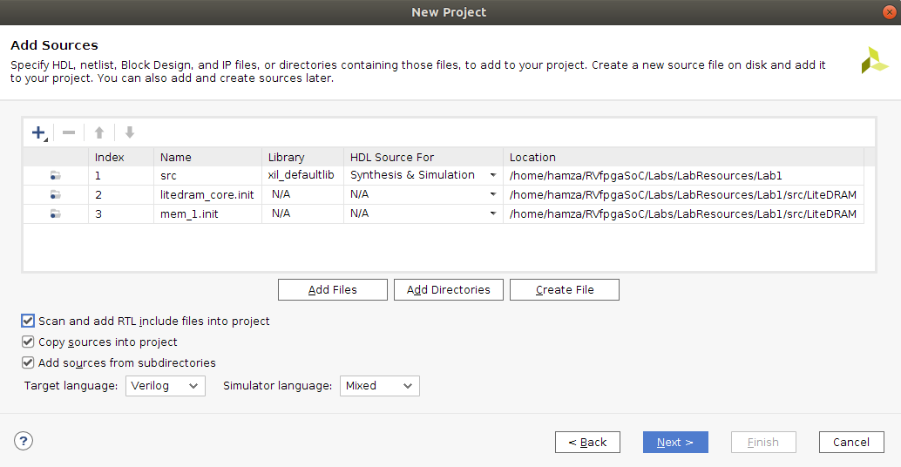

**Figure 11. Add Sources**

You will now add the constraints for the system. These files map the signal names to the pins on the board. For example, the Nexys A7 FPGA board’s LEDs are connected to FPGA pins on the board through the PCB traces. Vivado must know this to map the correct signal name in the RTL to the correct FPGA pin. For example, the following line in the *[RVfpgaSoCPath]/RVfpgaSoC/src/rvfpga.xdc* file, a Xilinx design constraints file, indicates that FPGA pin H17 maps to the least significant LED (o_led[0]) and that it uses LVCMOS 3.3V signalling:

set_property -dict { PACKAGE_PIN H17 IOSTANDARD LVCMOS33 } [get_ports { o_led[0] }]

Note that the signal name o_led is the name used in RVfpga’s Verilog code to drive the Nexys A7 board’s LEDs.

In the Add Constraints window, click on “**Add Files**” and select the following two files (See Figure 11):

*[RVfpgaSoCPath]/RVfpgaSoC/Labs/LabResources/Lab1/src/rvfpga.xdc*

*[RVfpgaSoCPath]/RVfpgaSoC/Labs/LabResources/Lab1/src/litedram.xdc*

Then click **Next**.

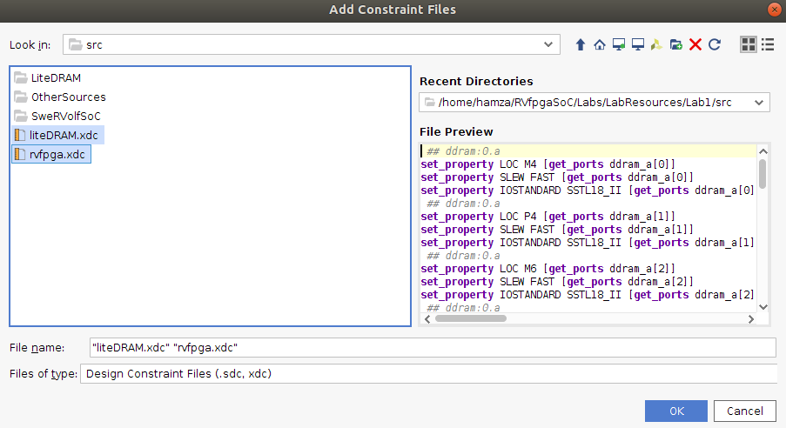

**Figure 12. Add Constraints**

**Step 4. Select Nexys A7 as the target board**

In the Default Part window, click on Boards and then select Nexys A7-100T (See Figure 13). You may use the Search box to narrow down the results. You will also notice that the name of the actual target FPGA is listed in the Part column: xc7a100tcsg324-1. This indicates that it is a Xilinx Artix-7 FPGA with 100k equivalent gates with a CSG (chip-scale grid) package and 324 pins.

Click Next.

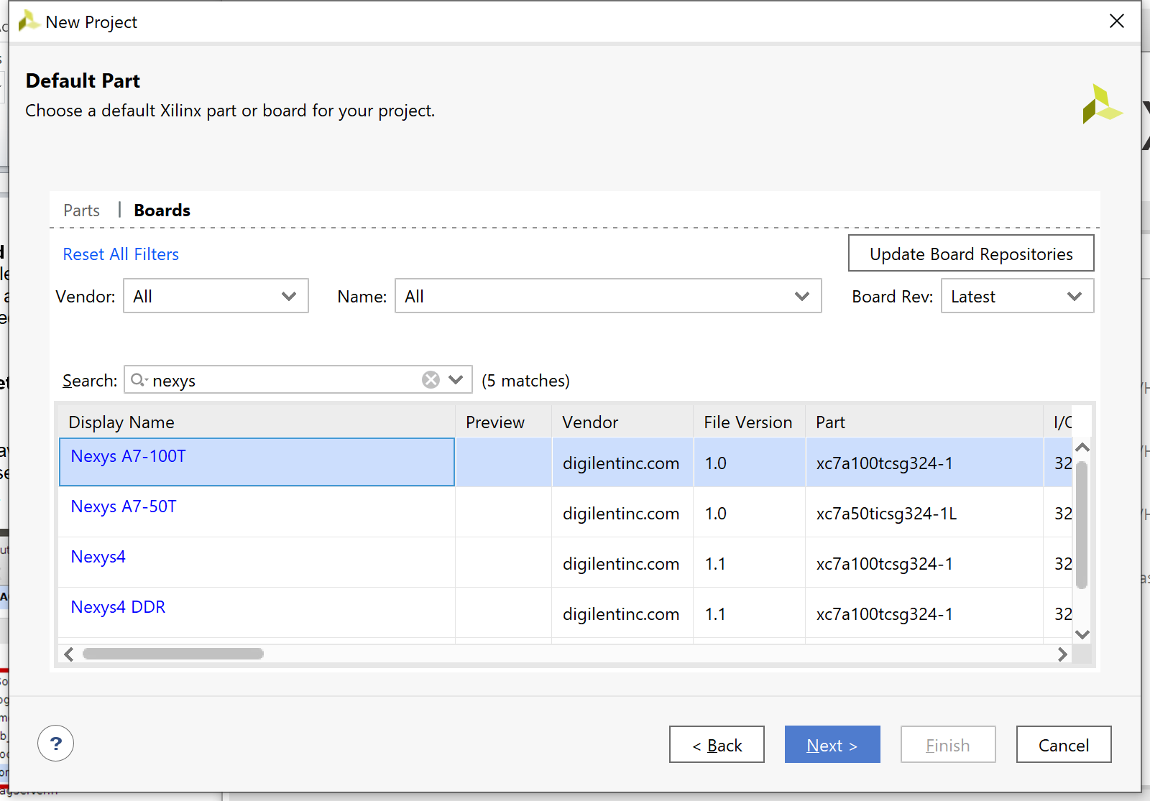

**Figure 13. Select target board: Nexys A7-100T**

In the New Project Summary window, click **Finish** (see Figure 14).

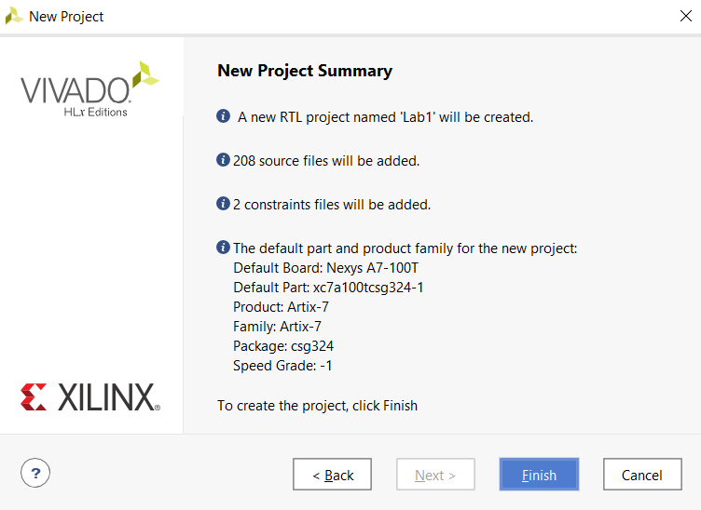

**Figure 14. New Project Summary Window**

Note that once the project completes being set up, it will indicate that files exist with Syntax Errors – this will be fixed in the next step.

**Step 5. Set rvfpga as Top Module**

The project will initialize. You will now set the rvfpga module as the top module. In the Sources pane, scroll down under Design Sources, right-click on the rvfpga module, and select Set as Top (see Figure 15). You can also find the rvfpga module by typing this name in the search box, as shown. This sets rvfpga as the highest-level module in the hierarchy and the target to be synthesized and implemented onto the FPGA. After setting rvfpga as the top module, the hierarchy will update.

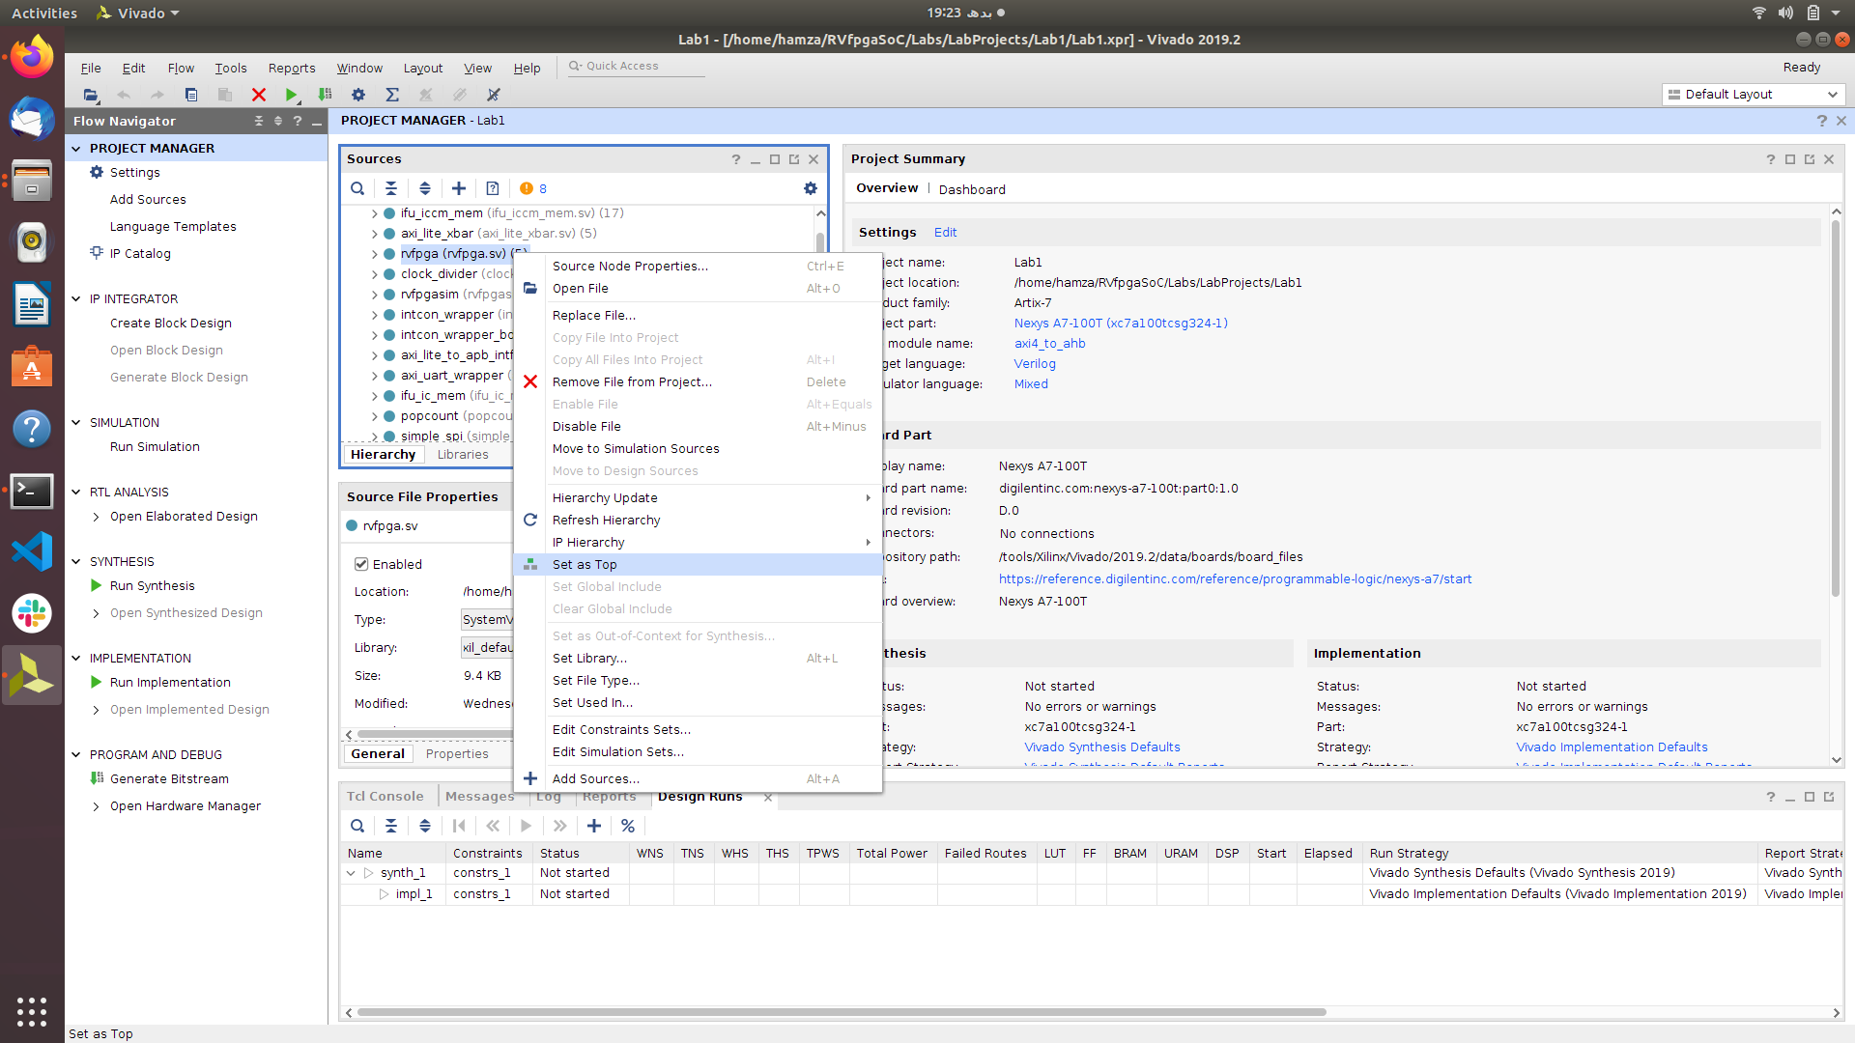

**Figure 15. Set rvfpga as top module**

**Step 6. Set Verilog header files as global include Files**

Now, still in the Sources pane under Design Sources, expand the Non-modules filegroup and click on common_defines.vh. The properties of the file will then open in the Source File Properties pane, just below the Sources pane. Click on Global Include to tick that box (see Figure 16). The hierarchy will now update and include that file in Design Sources/Global Include.

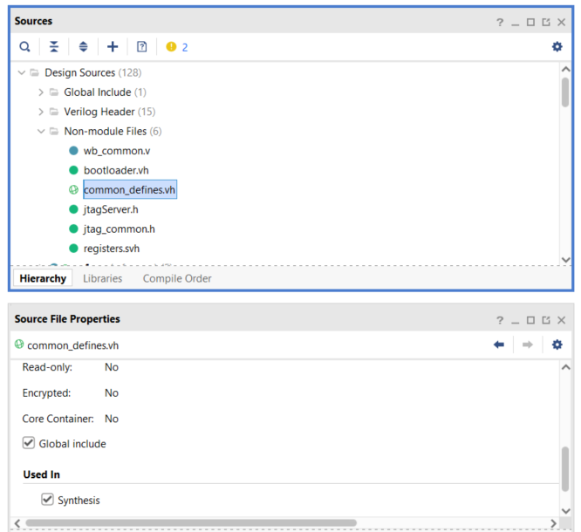

**Figure 16. Set common_defines.vh as a Global include file**

Similarly, set the **“assign.svh”**, **“registers.svh”**, and **“typedef.svh”** SystemVerilogHeader filesas global include files (See Figure 17).

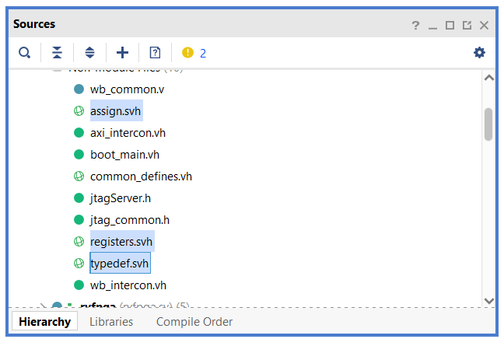

**Figure 17. Set “.svh” files as a Global include file**

Now expand the “**unknown**” filegroup and click on“**litedram_core.init**”. Then click on the Properties button next to the General button in the Source File Properties panel. Click on“**IS_Global_INCLUDE**” to tick that box (See Figure 18).

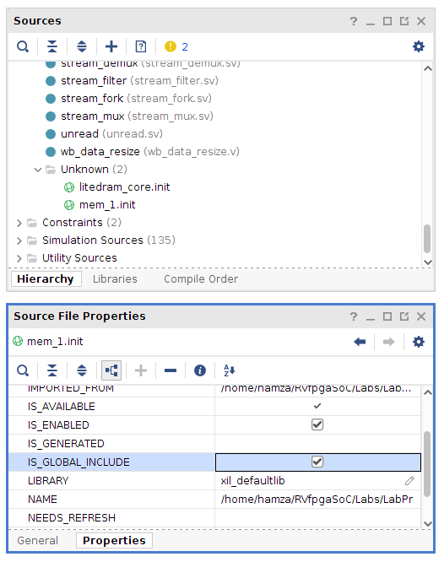

**Figure 17. Set litdram_core.init as a Global include file**

Now do the same for the “**mem_1.init**” file and set that file as a Global include file as well, just as did for the “**litedram_core.init**” file.

**Step 6. Add boot_main.mem to the project**

In the Flow Navigator pane, click on Add Sources, leave the default option (“Add or create design sources”), and click on Add Files (see Figure 18). Navigate to *[RVfpgaSoCPath]/RVfpgaSoC/Labs/LabResources/Lab1/src/SweRVolfSoC/BootROM/sw* and select *boot_main.mem* (as shown in Figure 18). The hierarchy will update and include that file in Design Sources/Memory File.

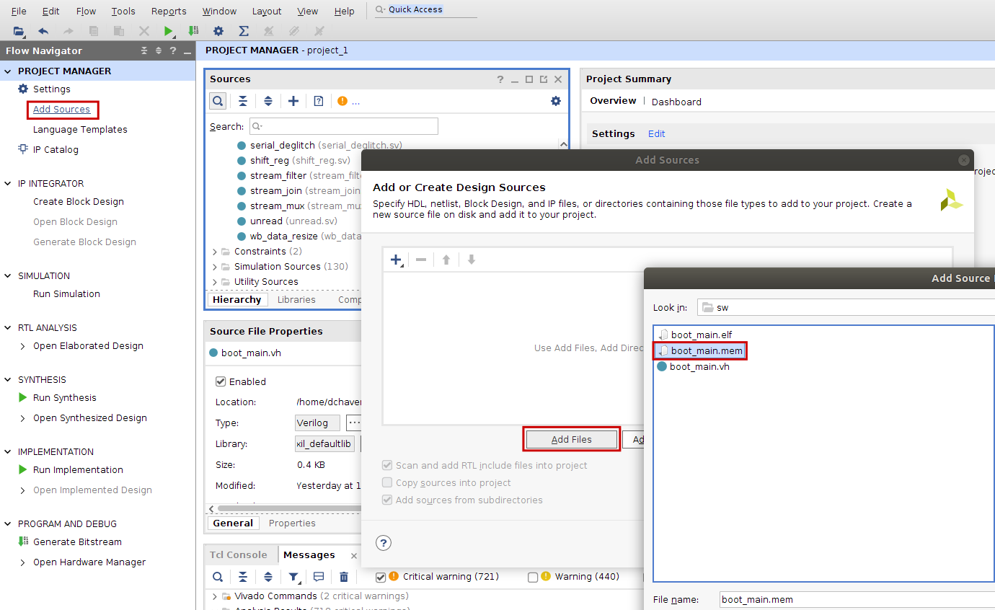

**Figure 18. Add Memory File boot_main.mem**

The design source files have now been added and now we can go ahead and start creating the block design.

# Create Block Design :

We will be using Vivado’s Block Design feature to add the modules required to create the SweRVolf and then wire them up with each other.

**Step 1. Click on Create Block Design**

Create a new block design in the Flow Navigator by clicking on Create Block Design under the IP Integrator heading (See Figure 18).

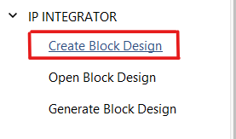

**Figure 18. Create Block Design**

**Step 2. Select Block Design’s Name**

Select the Design name as “**BD**” to avoid any naming conflicts later in the Lab (See Figure 19).

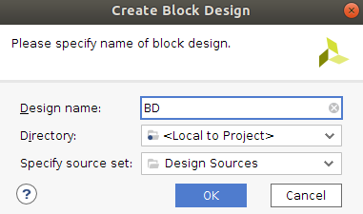

**Figure 19. Select Block Design’s Name and Directory**

Now you will see a blank block design Diagram panel. (See Figure 20)

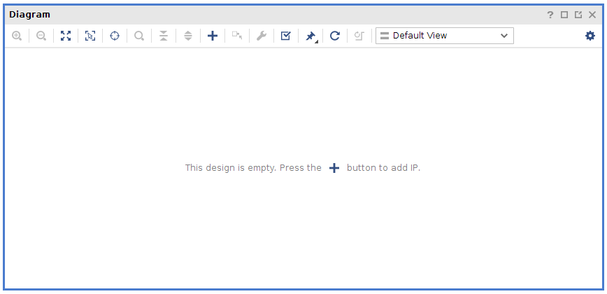

**Figure 20. Blank Block Design**

**Step 3. Add Modules to the Block Design**

Now we can start adding modules to our Block Design. We can do that by right-clicking on the blank Block design and select the “**Add Module**” option (See Figure 21).

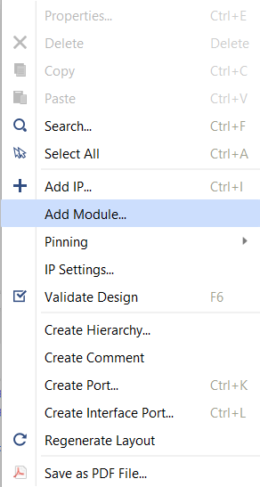

**Figure 21. Add Module**

A dialogue box will appear; you can either scroll down or type in the search box the name of the required modules you would like to add. We will start by adding the SweRV EH1 Core.

Select **“swerv_wrapper_verilog”** and click OK.

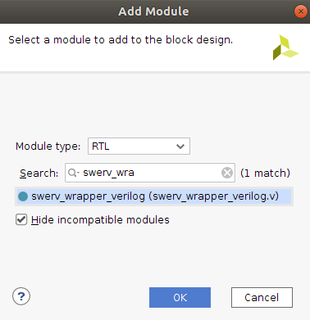

**Figure 22. Add Swerv_wrapper_verilog**

A critical warning message will pop up (See Figure 23). Click OK to ignore this warning message.

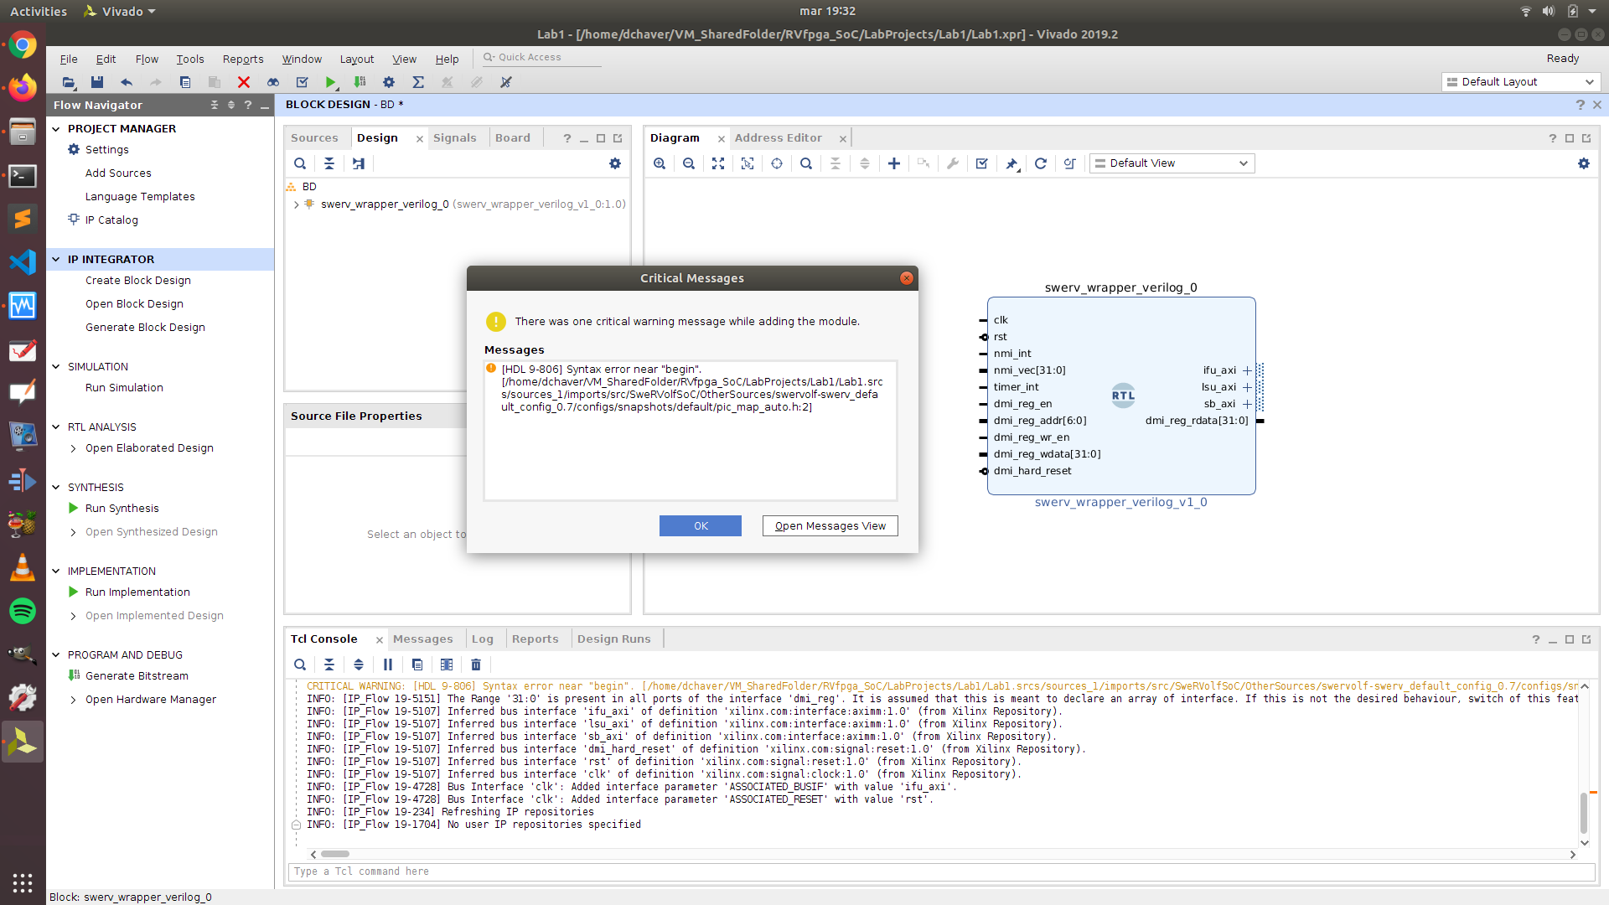

**Figure 23. critical warning message**

After we have added the module, we can visualize and access all the pins of “**ifu_axi**”, “**lsu_axi**” or “**sb_axi**” by clicking on the “**+**” icon on the module.

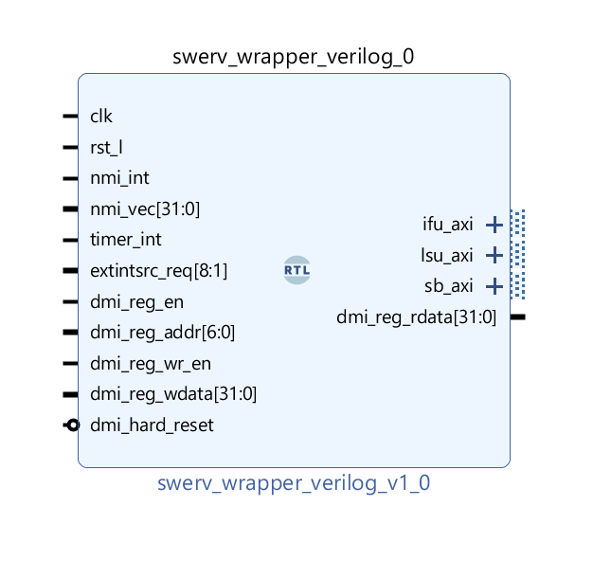

**Figure 24. Swerv_wrapper_verilog module has been added**

Similarly, we will now add the following modules :

* **“intcon_wrapper_bd”** (Interconnect Wrapper Module) : It is a wrapper module that contains all the three interconnect modules wrapped into it.



Now we will add the peripherals needed for our SoC :

* **“bootrom_wrapper”** (Boot-ROM Module)



* **“gpio_wrapper”** (GPIO Top Module)



* **“syscon_wrapper”** (System Controller Module)



We will add the 32 “**bidirec”** modules to attach with our GPIO module. 16 of these will be for the LEDs, and 16 will be for the switches.

* **“bidirec”** (Bidirectional GPIO module)



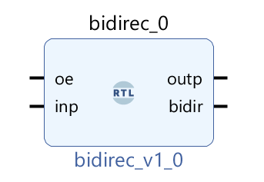

**Figure 25. bidir GPIO module**

Similarly, we will add 32 of these modules to the block design.

A quick way to add these 32 modules is to copy-paste the blocks in the Diagram. First Copy 1 “**bidirec**” block then paste it, then copy 2 blocks and paste them, then repeat the process of copying and pasting until you have 32 blocks of “bidirec” module added to your block design.

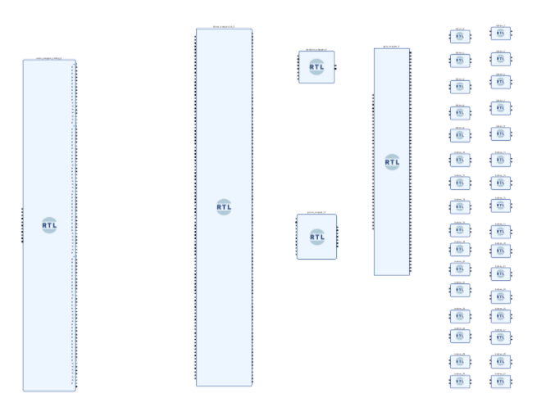

**Figure 26. Required modules have been added to the Block Design**

See Figure 26 for the following instructions. Starting from the left-hand side, view the **SweRV Core** module (swerv_wrapper_verilog_0); then, to the right, view the **Interconnect Wrapper** module (intcon_wrapper_0) and the four peripheral modules, which are the **Boot-ROM** (bootrom_wrapper_0) module, **System Controller** (syscon_wrapper_0) module, **GPIO** (gpio_wrapper_0) module. On the rightmost side, you will see the 32 **Bidirec** (bidirec_x) modules.

**Step 4. Wire up the modules**

We now wire the modules to each other pin-by-pin or, in some cases, bus-by-bus. We will begin connecting the “**swerv_wrapper_verilog**” with the “**intcon_wrapper_bd**”. Three different sets of pins need to be connected between these modules related to the following submodules of the core:

* **IFU** (Instruction Fetch Unit)
* **LSU** (Load Store Unit)
* **SB** (Store Byte)

We will first start with connecting the pins related to the IFU. Connect pin “ *ifu_axi_arid[2:0]* ” of “**swerv_wrapper_verilog**” module to the “*i_ifu_arid[2:0]* ” pin of the “**intcon_wrapper_bd**”.

Similarly,

*ifu_axi_araddr[31:0]*  will be connected to *i_ifu_araddr[31:0],*

*ifu_axi_arlen[7:0]* will be connected to *i_ifu_arlen[7:0],*

*ifu_axi_arsize[2:0]* will be connected to *i_ifu_arsize[2:0]* and so on.

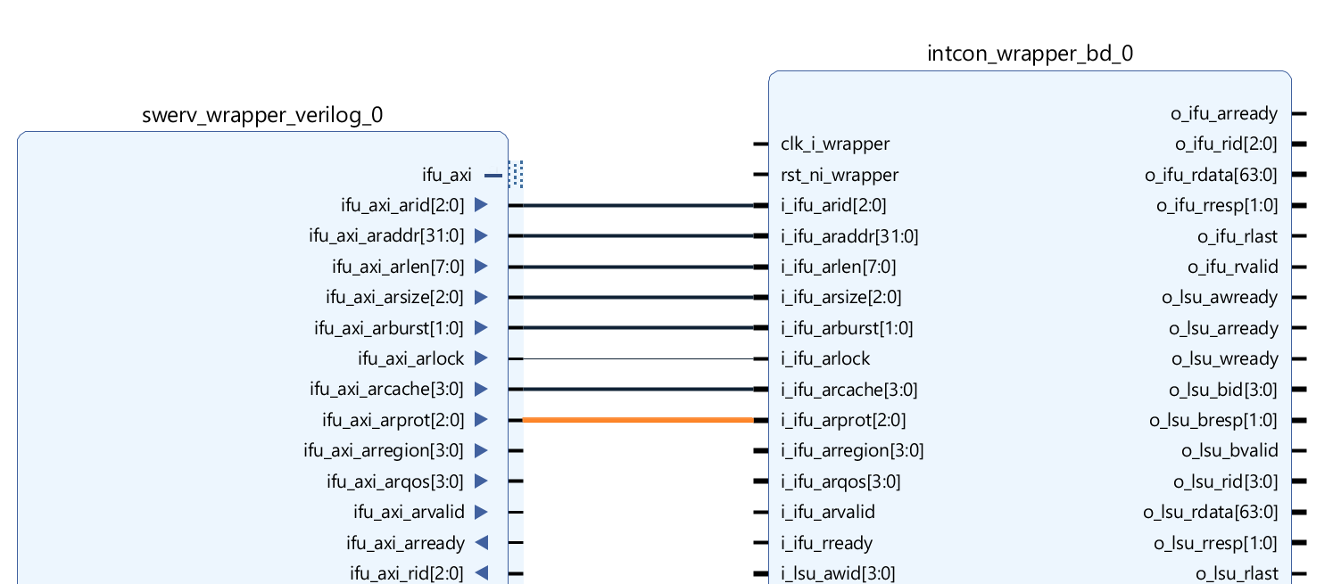

**Figure 27. Connect the relevant pin**

Similarly, we will connect all the **IFU** **(Instruction Fetch Unit)** pins of “**swerv_wrapper_verilog**” with the **IFU’s** pins of “**intcon_wrapper_bd**”.

**PDF:** High-quality PDFs of the Block Design showing close-up details of the wiring are available here:

[RVfpgaSoCPath]/RVfpgaSoC/Labs/LabResources/Lab1/BlockDesignPDFs

/InternalConnections/1_SwervW_IntconW_IFU.pdf

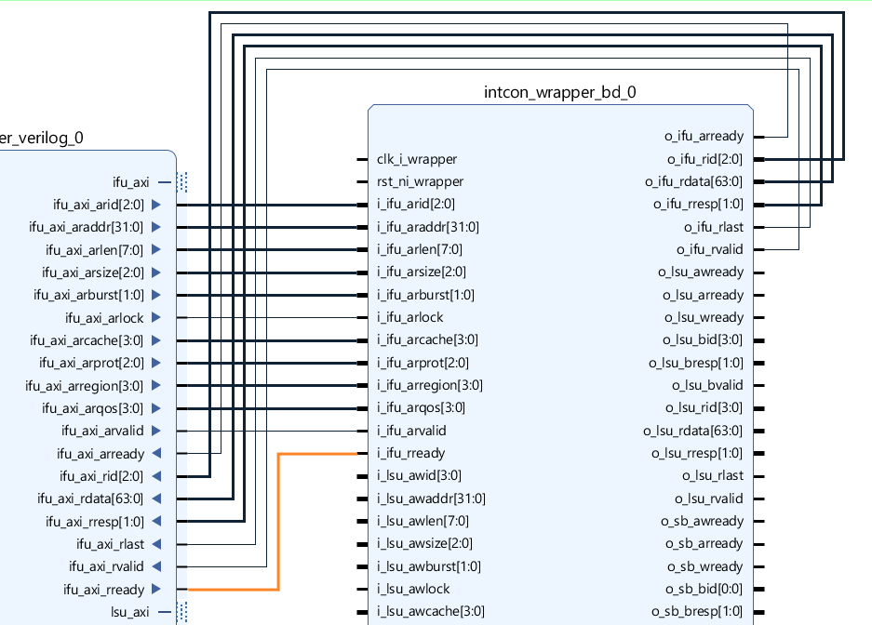

**Figure 28. Connect all the IFU pins**

Now we will move to connect all the **LSU (Load Store Unit)** pins of the “**swerv_wrapper_verilog**” to the **LSU’s** pins of “**intcon_wrapper_bd**”. We will perform the same process as we did for the **IFU** pins, connecting each **LSU** pin of the “**swerv_wrapper_verilog**” module with its respective pin on the “**intcon_wrapper_bd**” module.

**PDF:** High-quality PDFs of the Block Design showing close-up details of the wiring are available here

[RVfpgaSoCPath]/RVfpgaSoC/Labs/LabResources/Lab1/BlockDesignPDFs

/InternalConnections/2_SwervW_IntconW_LSU.pdf

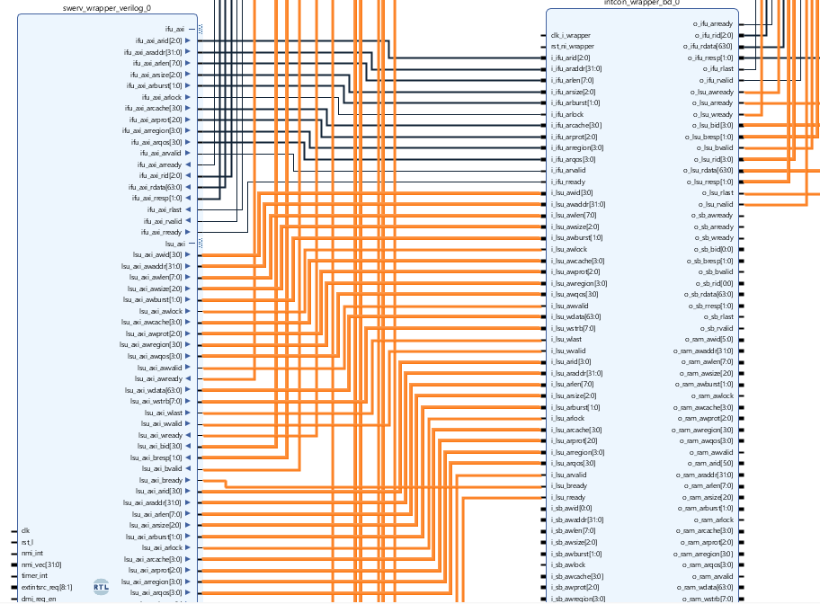

**Figure 29. Connect all the LSU pins**

Now we proceed to connect the **SB** pins. We similarly connect all the **SB** pins of the “**swerv_wrapper_verilog**” with its respective **SB’s** pins of “**intcon_wrapper_bd**”.

**PDF:** High-quality PDFs of the Block Design showing close-up details of the wiring are available here:

[RVfpgaSoCPath]/RVfpgaSoC/Labs/LabResources/Lab1/BlockDesignPDFs

/InternalConnections/3_SwervW_IntconW_SB.pdf

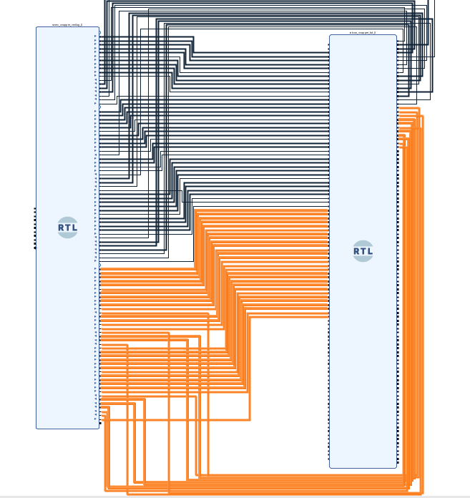

**Figure 30. Connect all the SB pins**

Next, we will connect the peripherals with the “**Intcon_wrapper_bd**”. We start with the “**bootrom_wrapper**” module by joining the “wb_rom_xxx_x” wires of the “**Intcon_wrapper_bd**”.

**PDF:** High-quality PDFs of the Block Design showing close-up details of the wiring are available here:

[RVfpgaSoCPath]/RVfpgaSoC/Labs/LabResources/Lab1/BlockDesignPDFs

/InternalConnections/4_BootRomW_IntconW.pdf

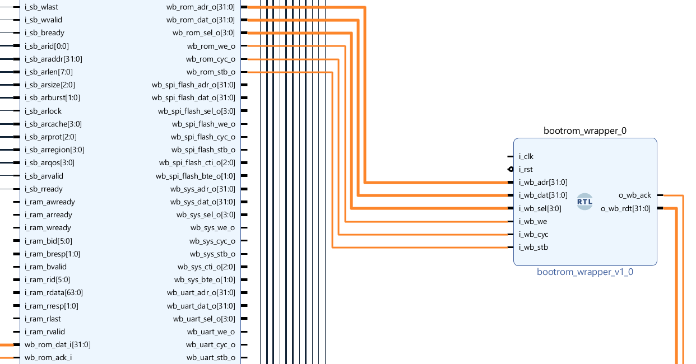

**Figure 31. Connect the BootROM module with the Interconnect Wrapper module**

Now we will connect the “**syscon_wrapper**” module with the “**Intcon _wrapper_bd**” module.

**PDF:** High-quality PDFs of the Block Design showing close-up details of the wiring are available here:

[RVfpgaSoCPath]/RVfpga-SoC/Labs/LabResources/Lab1/BlockDesignPDFs

/InternalConnections/5_SysconW_IntconW.pdf

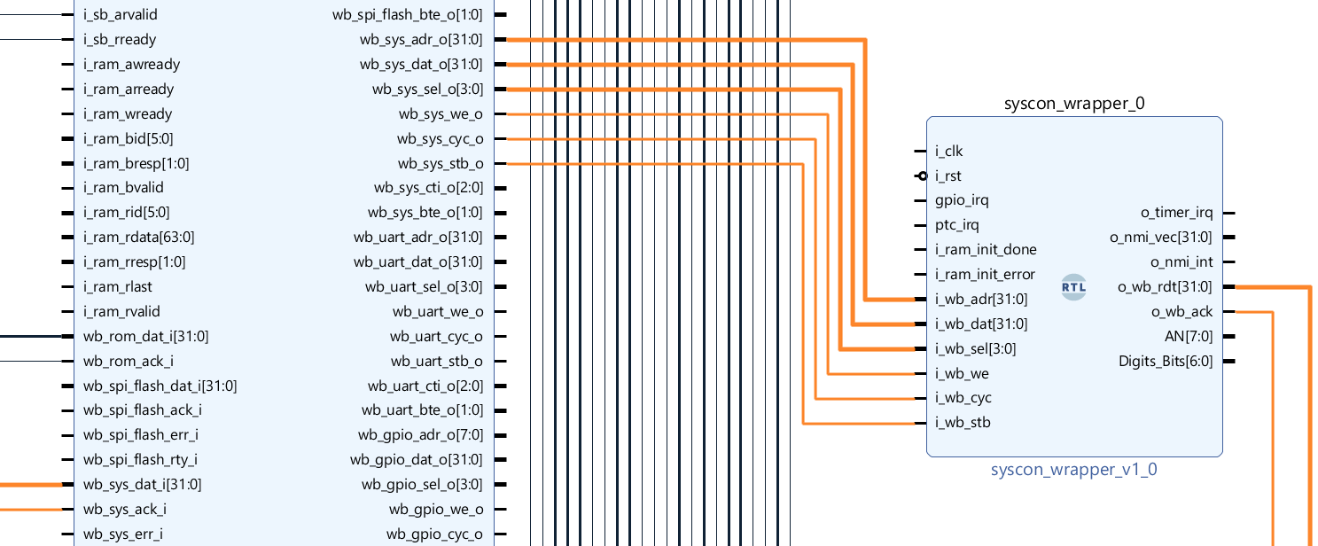

**Figure 32. Connect the Syscon with the WB Interconnect Pins**

The following pins of the “**syscon_wrapper**” will be connected to the “**swerv_wrapper_verilog**”.

* o_timer_irq
* o_nmi_vec[31:0]
* o_nmi_int

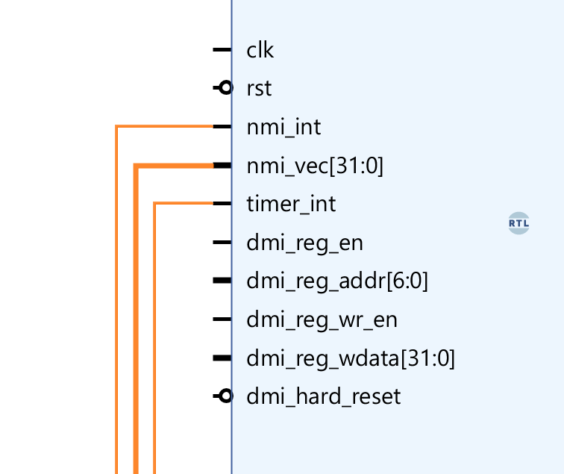

**Figure 33. Connect the syscon_wrapper with the swerv_wrapper_verilog pins**

Now we will connect the “**gpio_wrapper**” module with the “**intcon_wrapper_bd**”. Connect the “wb_gpio_xxx_x” pins of the “**intcon_wrapper_bd**” module with the “**gpio_wrapper**” module pins.

Connect the “**wb_inta_o**” pin of the “**gpio_wrapper**” module with the “**gpio_irq**” pin of the “**syscon_wrapper**” module.

**PDF:** High-quality PDFs of the Block Design showing close-up details of the wiring are available here:

[RVfpgaSoCPath]/RVfpgaSoC/Labs/LabResources/Lab1/BlockDesignPDFs

/InternalConnections/6_GpioW_IntconW.pdf

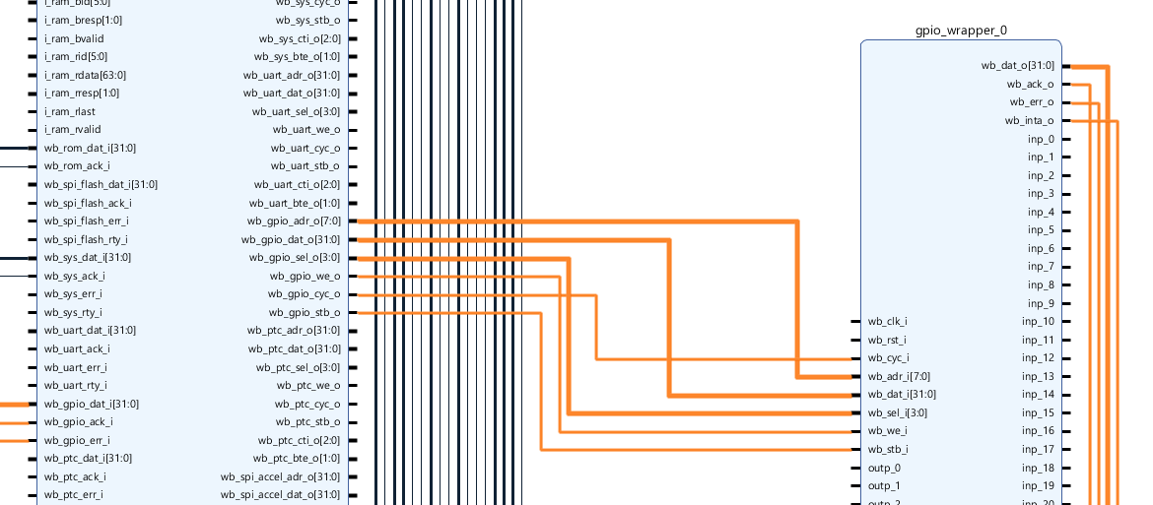

**Figure 34. Connect the gpio_wrapper with the intcon_wrapper pins**

We will connect the 32 GPIO “**bidirec**” modules with our “**gpio_wrapper**” module that we have already connected. Specifically, we will connect the “**gpio_wrapper**” module with the “**bidirec_x**” modules, where x is a number from 1 to 32. The connections will go as follows:

*“****inp_0****”* pin of “**gpio_wrapper_0”** will be connected to **“*inp”***of “**bidirec_0**”,

*“****inp_1****”* pin of “**gpio_wrapper_0**” will be connected to **“*inp”***of “**bidirec_1**”, and similarly these connections will go till the last “***inp***” connection, which is “**inp_31**” of “**gpio_wrapper**” will be connected to “***inp***” of “**bidirec_31**”.

Similarly,

*“****oe_0****”* pin of “**gpio_wrapper_0”** will be connected to **“*oe”***of “**bidirec_0**”,

*“****oe_1****”* pin of “**gpio_wrapper_0**” will be connected to **“*oe”***of “**bidirec_1**”, and similarly these connections will go till the last “***oe***” connection, which is “**oe_31**” of “**gpio_wrapper**” will be connected to “***oe***” of “**bidirec_31**”.

and similarly again,

*“****outp_0****”* pin of “**gpio_wrapper_0”** will be connected to **“*outp”***of “**bidirec_0**”,

*“****outp_1****”* pin of “**gpio_wrapper_0**” will be connected to **“*outp”***of “**bidirec_1**”, and similarly these connections will go till the last “***outp***” connection, which is “**outp_31**” of “**gpio_wrapper**” will be connected to “***outp***” of “**bidirec_31**”.

**PDF:** High-quality PDFs of the Block Design showing close-up details of the wiring are available here:

[RVfpgaSoCPath]/RVfpgaSoC/Labs/LabResources/Lab1/BlockDesignPDFs

/InternalConnections/7_GpioW_32xBidirec.pdf

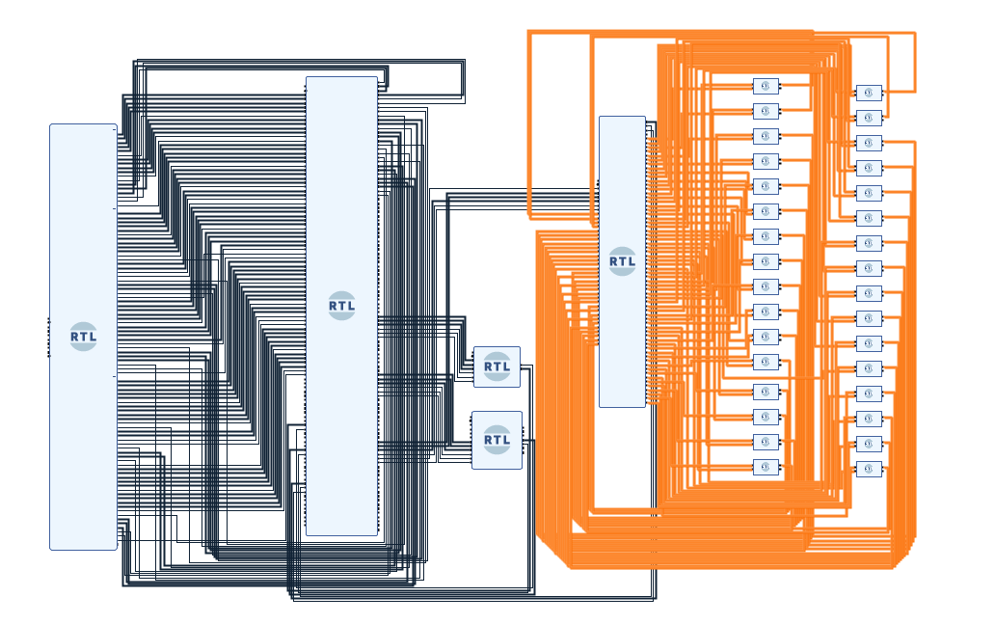

**Figure 35. All GPIO Bidirec Modules connected to gpio_wrapper module**

Now that we have connected all the internal connections between the modules, we will now make the external connections.

**Step 5. Make External Connections for I/OPins**

Now it is time to connect the pins coming into our block design as an Input or going out of our block design as an Output. We will connect these pins as the external Pins/Ports. These external pins include the pins of **RAM** (DDR), **CLK** (Clock), **RST** (Reset), and **DMI** (Debug Module interface).

We begin by connecting the “**clk**” pin. Go to the “**swerv_wrapper_verilog**” module, right-click on the “**clk**” pin, and you will see a dropdown (See Figure 36). Select the option of Make External from among all the dropdown options. You can also left-click on the pin and use the shortcut key “CTRL + T” to make the pin External.

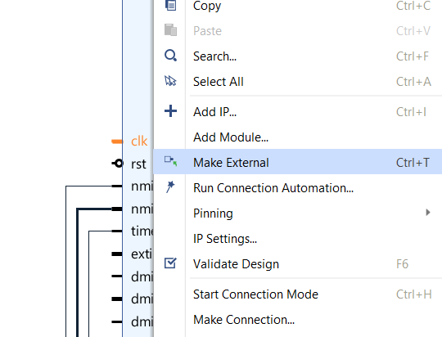

**Figure 36. Make “clk” an external connection**

You will now see the “**clk**” pin of “**swerv_wrapper_verilog**” connected to an external pin “**clk_0**” (See Figure 37).

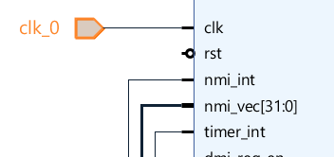

**Figure 37. “clk” becomes an external connection**

Now we can connect the **“clk”** external pin to the rest of the modules, including the intcon_wrapper_bd, syscon_wrapper, bootrom_wrapper, and gpio_wrapper.

**PDF:** High-quality PDFs of the Block Design showing close-up details of the wiring are available here:

[RVfpgaSoCPath]/RVfpgaSoC/Labs/LabResources/Lab1/BlockDesignPDFs

/ExternalConnections/1_Clock.pdf

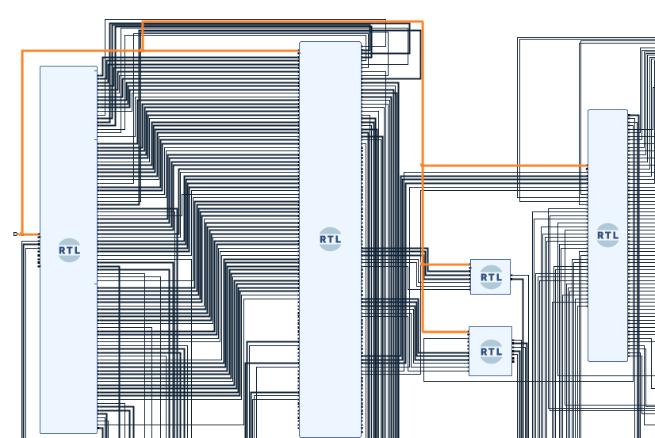

**Figure 38. Signal clk Connected to all modules**

Similarly, we can connect the **“rst”** pin to all the modules.

Like the external pin we created for “**clk**”, we will create for “**rst**”. Now again, go to the “**swerv_wrapper_verilog**” module and right-click on the “**rst**” pin, and make it external.

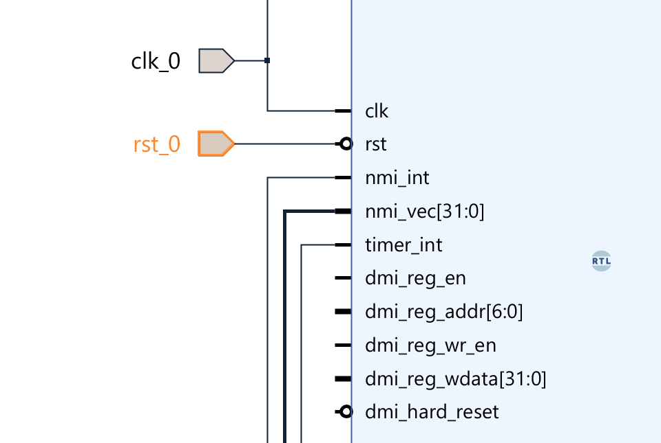

**Figure 39. Make rst_l as an external pin**

Now we will connect the **“rst_0”** external pin to the rest of the modules, including the intcon_wrapper, syscon_wrapper, bootrom_wrapper, and gpio_wrapper.

**PDF:** High-quality PDFs of the Block Design showing close-up details of the wiring are available here:

[RVfpgaSoCPath]/RVfpgaSoC/Labs/LabResources/Lab1/BlockDesignPDFs

/ExternalConnections/2_Reset.pdf

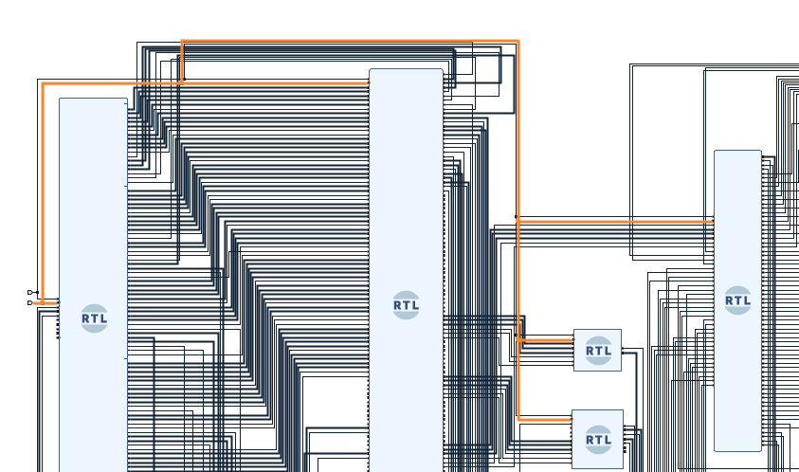

**Figure 40. Connect the Inverted “rst_0” pin with the rest of the modules**

Now we will connect all the RAM (DDR) pins of the “**Intcon_wrapper_bd**” module to the external RAM pins by completing the following steps.

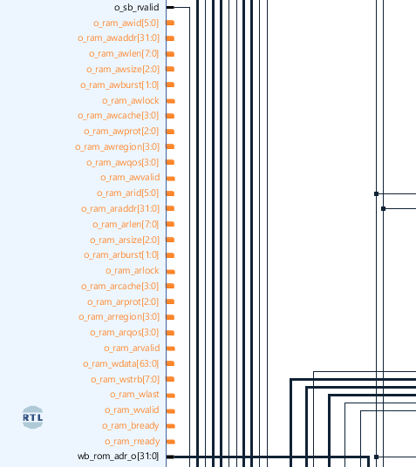

**Figure 41. Intcon wrapper right-hand side RAM pins**

We will now make all the right-hand side RAM pins in the “**Intcon_wrapper_bd**” module as external pins (See Figure 42).

**PDF:** High-quality PDFs of the Block Design showing close-up details of the wiring are available here:

[RVfpgaSoCPath]/RVfpgaSoC/Labs/LabResources/Lab1/BlockDesignPDFs

/ExternalConnections/3_RAM_R.pdf

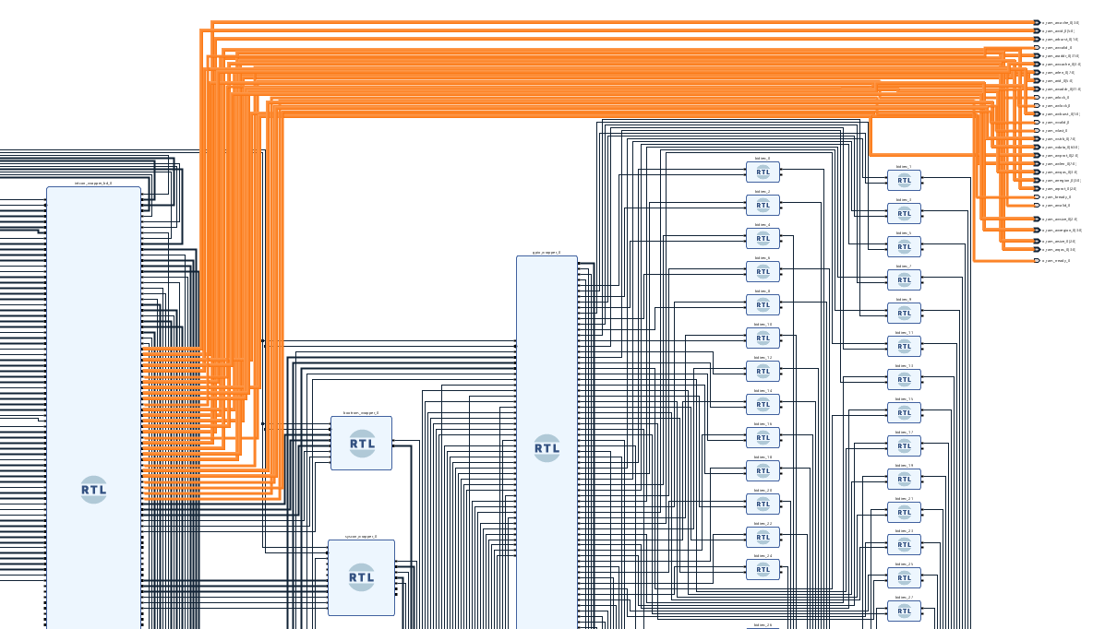

**Figure 42. Make all the right-hand side RAM pins as External**

Now we will make the left-hand side RAM pins of “**Intcon_wrapper_bd**” into external pins.

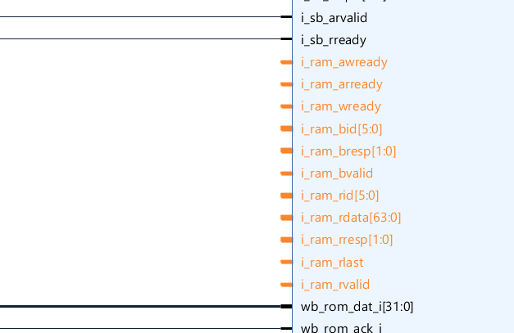

**Figure 43. Left Side RAM Pins of Interconnect Wrapper**

We will make all these RAM pins as external pins (See Figure 44).

**PDF:** High-quality PDFs of the Block Design showing close-up details of the wiring are available here:

[RVfpgaSoCPath]/RVfpgaSoC/Labs/LabResources/Lab1/BlockDesignPDFs

/ExternalConnections/4_RAM_L.pdf

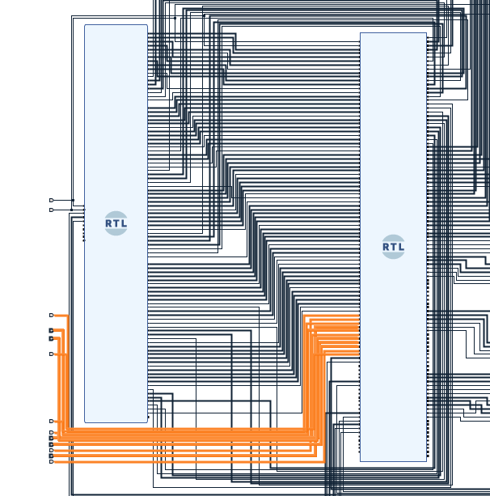

**Figure 44. Make all the left-hand side RAM pins as External**

Now we will connect the **DMI** pins of the **“swerv_wrapper_verilog”** module with the external pins.

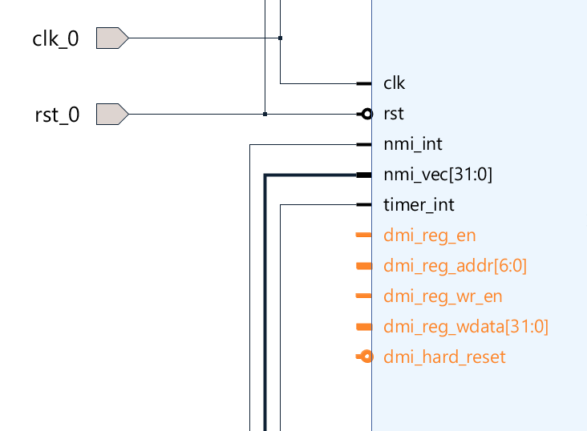

**Figure 45. dmi pins op swerv_wrapper_verilog (Left Side)**

**PDF:** High-quality PDFs of the Block Design showing close-up details of the wiring are available here:

[RVfpgaSoCPath]/RVfpgaSoC/Labs/LabResources/Lab1/BlockDesignPDFs

/ExternalConnections/5_DMI.pdf

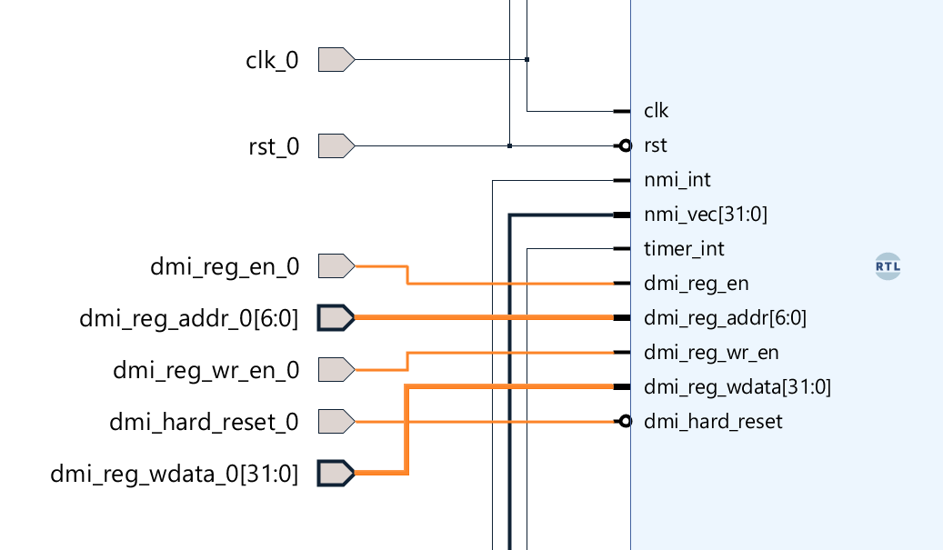

**Figure 46. Making dmi pins as External Pins**

We will connect one more pin with the external pin on the bottom right-hand side of the “**swerv_wrapper_verilog**” module. This pin is “dmi_reg_rdata[31:0]”.

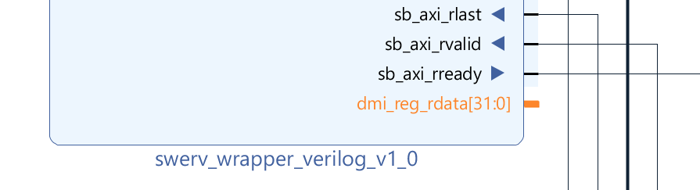

**Figure 47. “dmi_reg_rdata[31:0]” Pin (Right Side of swerv_wrapper_verilog)**

We will make “**dmi_reg_rdata[31:0]**” as an external pin as well.

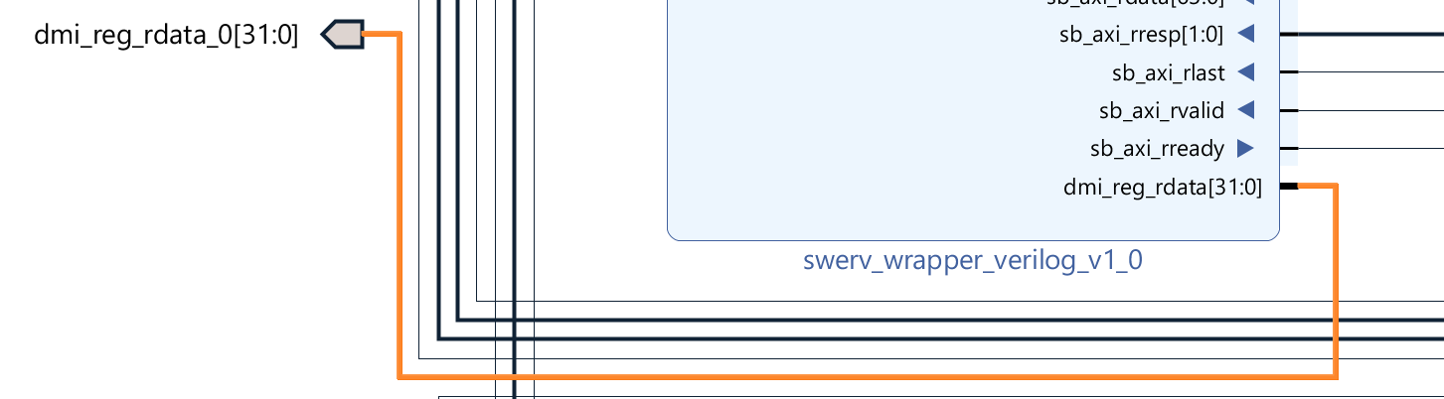

**Figure 48. Make “dmi_reg_rdata[31:0]” Pin as an External Pin**

We will now make the following pins of the “**syscon_wrapper**” module as external pins.

* i_ram_init_done
* i_ram_init_error
* AN[7:0]
* Digital_Bits[6:0]

**PDF:** High-quality PDFs of the Block Design showing close-up details of the wiring are available here:

[RVfpgaSoCPath]/RVfpgaSoC/Labs/LabResources/Lab1/BlockDesignPDFs

/ExternalConnections/6_SysconW_External.pdf

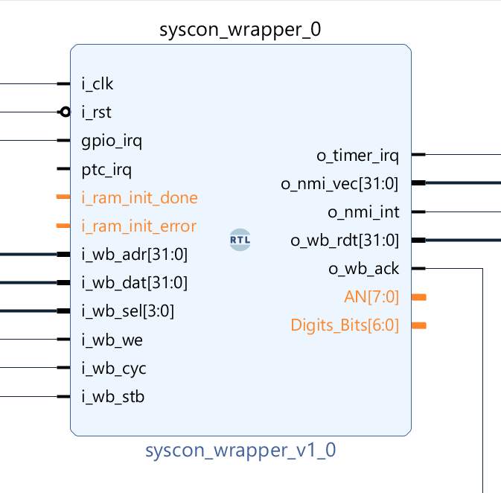

**Figure 49. syscon_wrapper’s external pins**

The last connection left is to make all the bidir pins of all the “**bidirec**” modules as external pins.

|  |
| --- |
| **Note:** Make these connections external one by one starting from the “**bidirec_0**” module  so the “**bidir**” pin of the “**bidirec_0**” module will be connected to an external pin  “**bidir_0**”. Then go to the “**bidir**” pin of “**bidirec_1**”, and so on. |

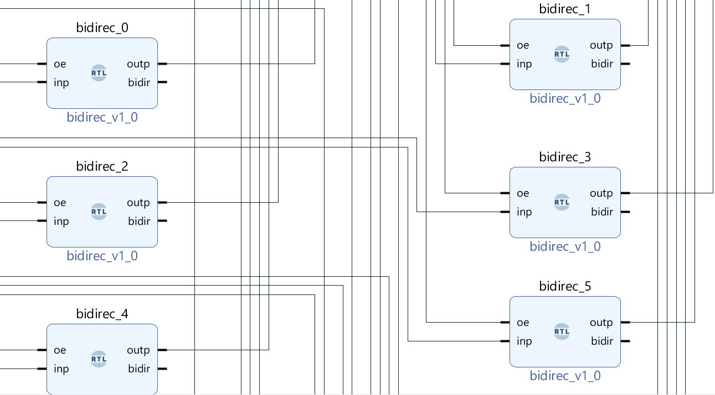

**Figure 50. Make “bidir” Pin of our GPIO Bidirec Modules as External Pins**

**PDF:** High-quality PDFs of the Block Design showing close-up details of the wiring are available here:

[RVfpgaSoCPath]/RVfpgaSoC/Labs/LabResources/Lab1/BlockDesignPDFs

/ExternalConnections/7_Bidir.pdf

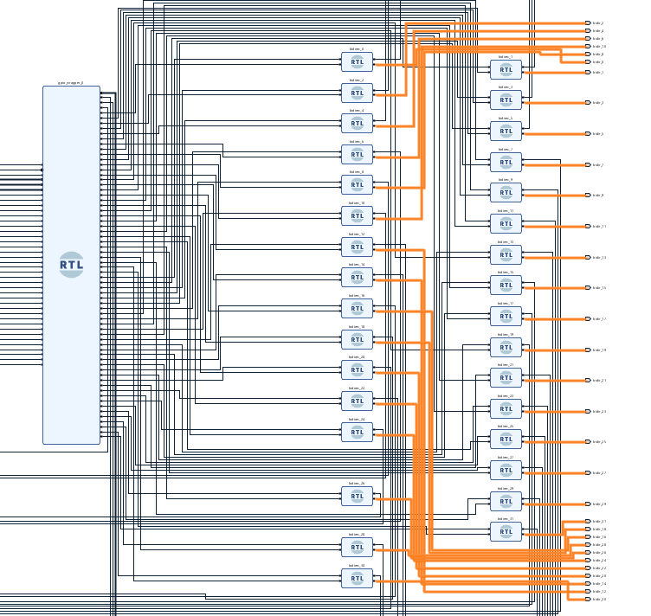

**Figure 51. Make “bidir” External connections**

Now we have completed all of the both internal and external connections for the RVfpga-SoC. Press “**Ctrl + S**” to save the block design.

Our RVfpga-SoC block design, which is modeled after the SweRVolf SoC, now contains the following connected modules:

* 1 SweRV Core (swerv_wrapper_verilog)
* 1 Interconnect Wrapper (intcon_wrapper_bd)
* 1 Boot-ROM (bootrom_wrapper)
* 1 GPIO Top Module (gpio_wrapper)
* 1 System Controller (syscon_wrapper)
* 32 Bidirec Gpio Module (bidirec)

See Figure 52.

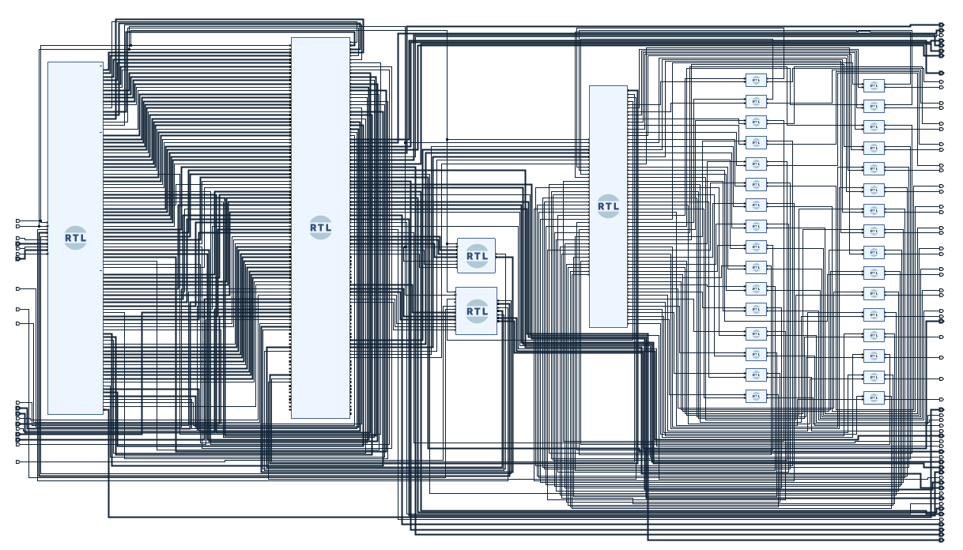**Figure 52. SweRVolf is complete for now**

# Generating swervolf module Verilog File :

We will now generate the Verilog file of our SweRVolf that we just created in the block design.

Navigate to the sources panel and find the Block Design Module “**BD**” that we just created.

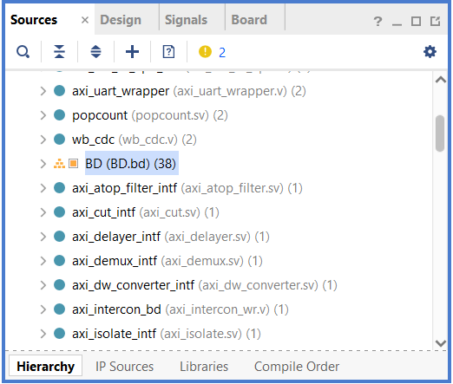

**Figure 53. Find “BD” in Sources**

Now right-click on that Block Design and then select “**Create HDL Wrapper**” (See Figure 54).

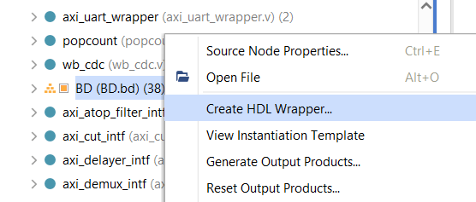

**Figure 54. Create HDL Wrapper**

Select the “**Let Vivado manage wrapper and auto-update**” option and click OK to proceed.

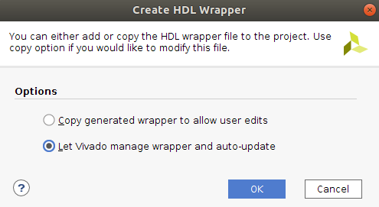

**Figure 55. Select the second Option**

You will see a pop-up of critical warnings because we have left several pins in our block design unconnected so that these pins will be automatically connected to “**0**” (ground).

Click OK.

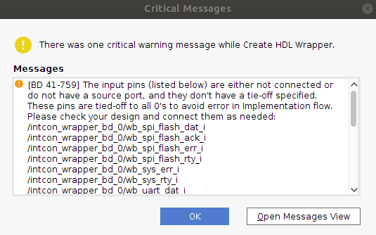

**Figure 56. Warning Pop-Up**

Now your HDL Wrapper is created. You can navigate to the Sources panel and scroll down until you see “**BD_wrapper**”. Click on the dropdown icon next to it and then again for “**BD_i**”.

Now open the “**BD (BD.v)**” file by double-clicking on it (See Figure 57).

We will call this “**BD.v**” Verilog file the “swervolf module file”.

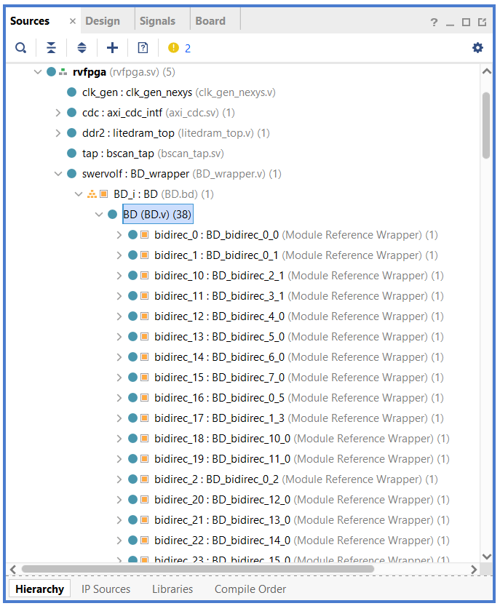

**Figure 57. Find “BD.v” in the sources panel**

Here you see the “**BD.v”** Verilog file that has been created using Vivado’s Block Design tool.

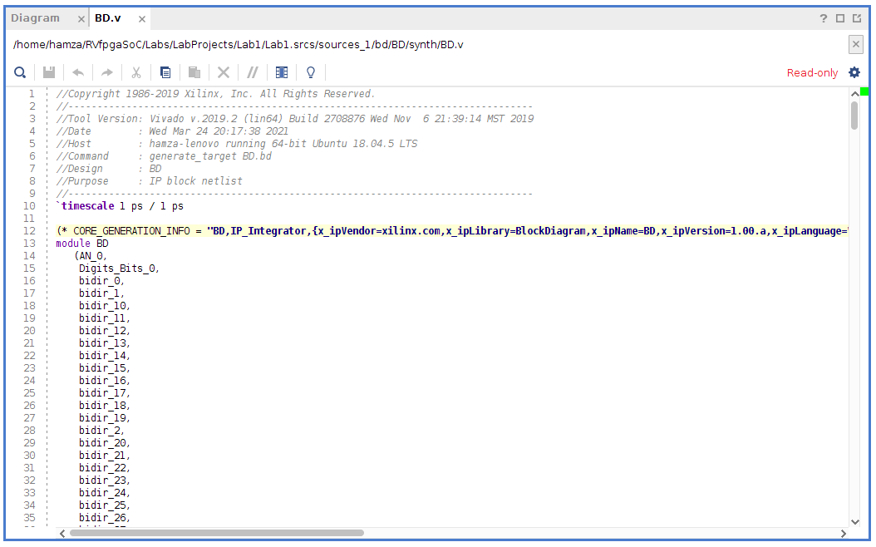

**Figure 58. “BD.v” The Verilog file of Swervolf Core**

You can see this newly created file’s path at the top of the file. In the next Lab, we will use this path to access this “**BD.v**” file.

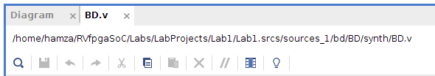

**Figure 59. Path of the “BD.v” file**

# Generate Bitstream

Now that we have created RVfpga-SoC using Vivado’s Block Design tool and generated a Verilog wrapper, we are ready to generate the bitstream which we will use to configure the FPGA. To generate the bitstream, we will first need to adjust some settings in Vivado by completing the following steps.

**Step 1**. **Navigate to Settings.**

Go to “**Tools**” in the upper left side of the Navigation Bar of Vivado, then select “**Settings**” from the options.

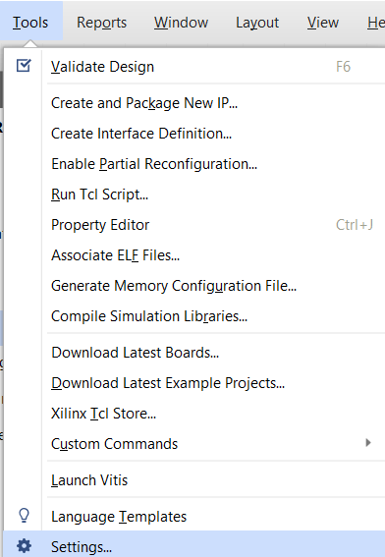

**Figure 60. Go to Settings**

**Step 2**. **Navigate to the General tab**

Go to the “**General**” tab, then select “**Verilog options**” from the language options section.

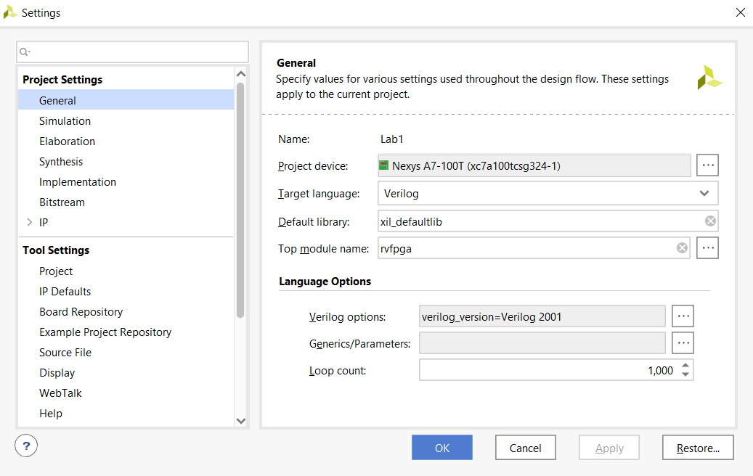 

**Figure 61. General Settings**

**Step 3**. **Add the path to the include files.**

Click on the “**+**”button to add the Verilog search path **Include Files**.

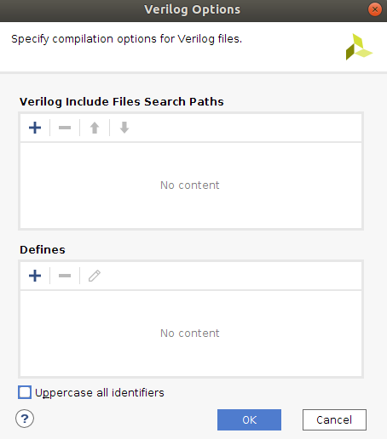

**Figure 62. Verilog Options**

Now add the following four paths :

* [RVfpgaSoCPath]/RvfpgaSoC/Labs/LabProjects/Lab1/Lab1.srcs /sources_1/imports/src/SweRVolfSoC/Interconnect

/AxiInterconnect/pulp-platform.org__axi_0.25.0/include

* [RVfpgaSoCPath]/RvfpgaSoC/Labs/LabProjects/Lab1/Lab1.srcs

/sources_1/imports/src/OtherSources

/pulp-platform.org__common_cells_1.20.0/include

* [RVfpgaSoCPath]/RvfpgaSoC/Labs/LabProjects/Lab1/Lab1.srcs

/sources_1/imports/src/SweRVolfSoC/SweRVEh1CoreComplex/include

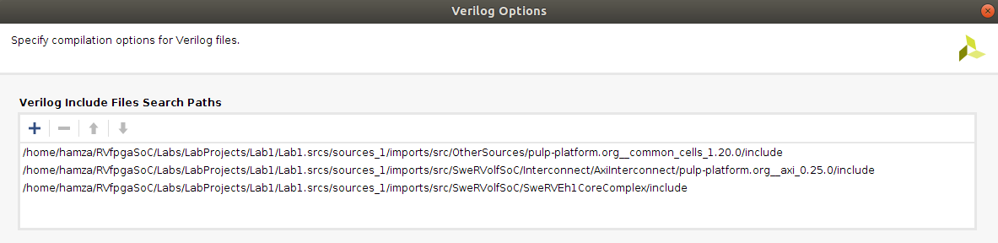

**Figure 63. Verilog Include Files Paths**

Click OK.

**Step 4**. **Navigate to the Bitstream tab**

Go to the “**Bitstream**” tab, then select “**tcl.pre**” from the language options section.

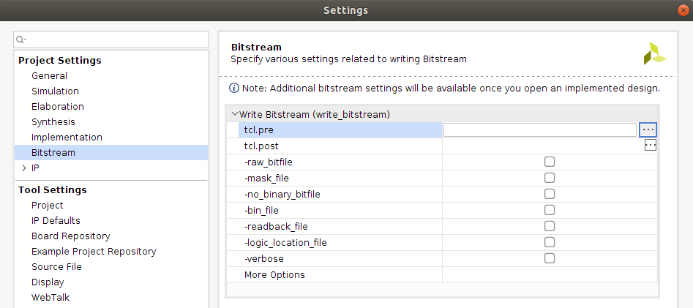

**Figure 64. Bitstream setting**

Select “New script” option.

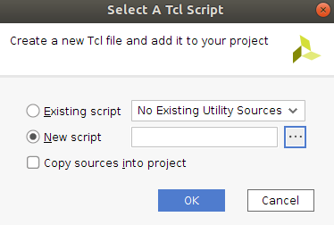

**Figure 65. New Tcl script**

Navigate to the following path and select the “script.tcl” file. (See Figure 66)

[RVfpgaSoCPath]/RVfpgaSoC/Labs/LabResources/Lab1/script.tcl

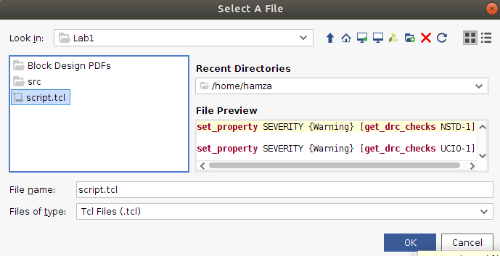

**Figure 66. import “script.tcl” file**

Click OK and apply the changes.

**Step 4**. **Generate Bitstream.**

Now Click on Flow → Generate Bitstream, as shown in Figure 67.

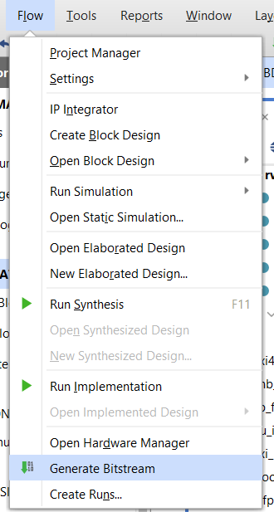

**Figure 67. Generate Bitstream**

A window might pop up that says there are no implementation results available and ask to launch synthesis and implementation.

Click Yes (see Figure 68).

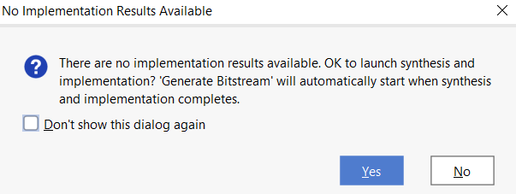

**Figure 68. Launch synthesis and implementation window**

The **Launch Runs** window will pop up on the screen (See Figure 69). Click OK.

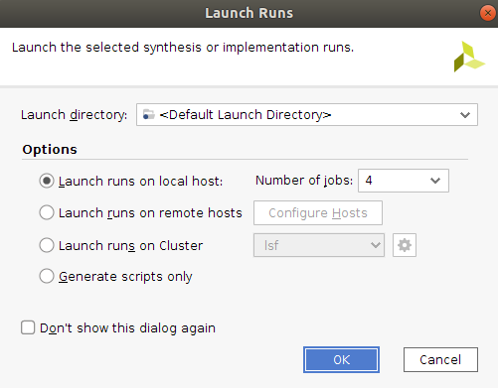

**Figure 69. Launch Runs**

Now we will see a list of warnings that tell us about the pins we left unconnected will be automatically connected to ”**0**”. We will click OK. (See Figure 70).

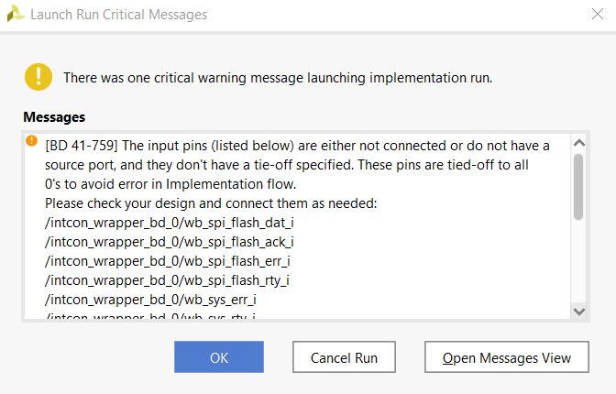

**Figure 70. Launch Runs Warning Messages**

This step synthesizes RVfpga (as defined by the Verilog and SystemVerilog files in the project), maps it onto the FPGA, and creates the bitstream.

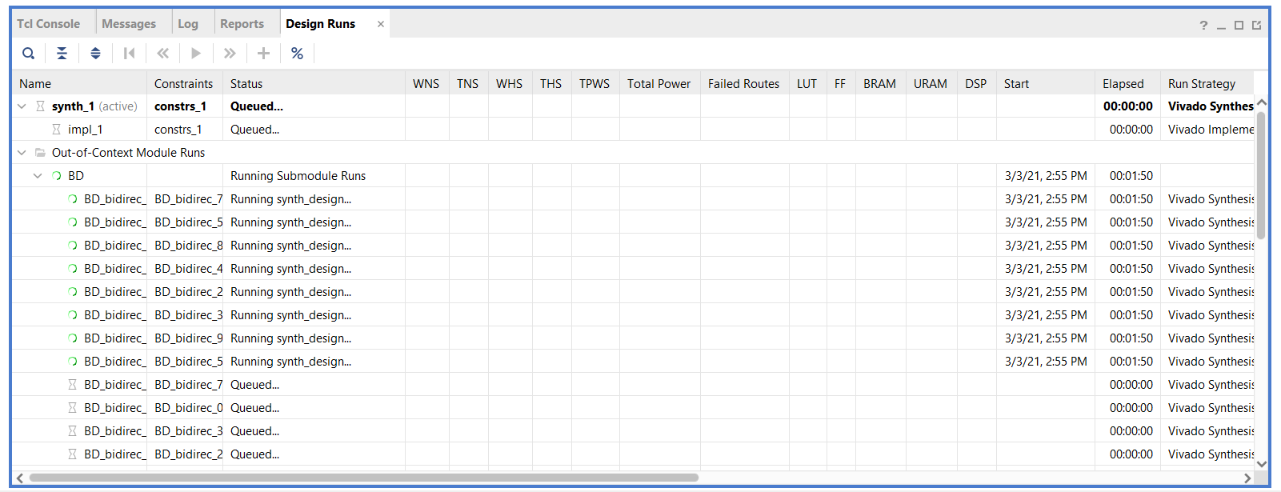

**Figure 71. Design Runs**

|  |
| --- |
| **Note:**  If you get an error like : Gtk-Message: Failed to load module "canberra-gtk-module"  Install a package by the following command to solve the issue.    sudo apt install libcanberra-gtk-module libcanberra-gtk3-module |

This process may take several minutes, depending on your computer’s speed.

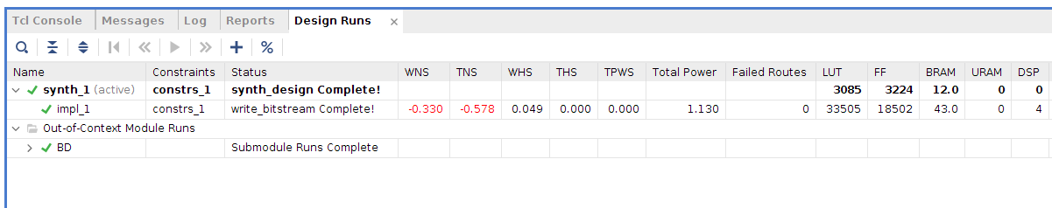

**Figure 72. Verilog Include Files Path**

After the bitstream has been generated, a window will pop up, as shown in Figure 73. Click on the X button in the top-right corner to close the window.

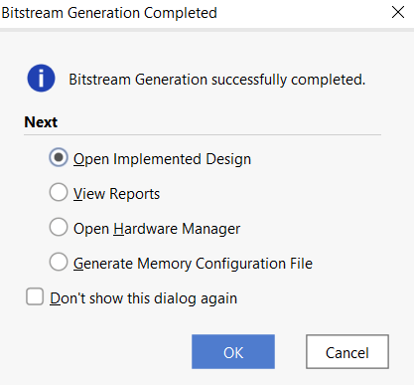

**Figure 73. Bitstream Generation Completed**

Now that the bitstream has been created, In the next Lab, we will show how to upload this bitstream onto a Nexys A7 board via PlatformIO, and then we will show how to run example programs on the RVfpga-SoC system we just built.